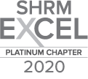
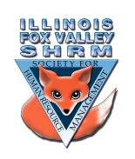
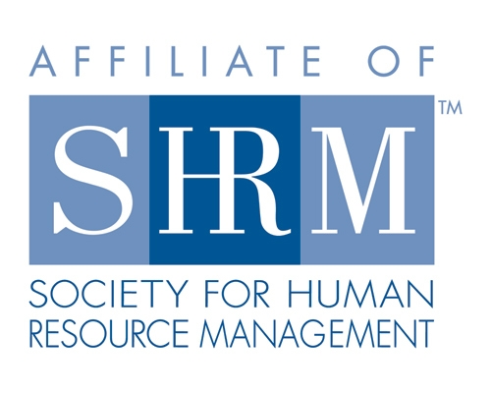

Board of
Board Meeting Minutes
Friday, April 23, 2021
Start time 8:30 am

Sarah Sester called the meeting to order at 8:34am
Mandatory vaccinations?
In person meetings?
-some groups in Illinois have been starting to come back
-check to see if Elgin country club is allowing in person meetings
-do people get to continually be remote or do they have to be in person for a few meetings
-do we have the technology?

Kristen’s other SHRM group has one meeting scheduled in the fall
-she has been talking to Harper College regarding meeting there – they can’t schedule anything yet

Lisa wonders if Elgin Community College can host us

Kristen will reach out at Elgin County Club
Sarah – probably not have any requirements until 2022
Sue – maybe we offer it as a hybrid for now
Sarah – maybe shoot for July legal update as first hybrid meeting
-people seem to like that idea
-Lisa suggested publicizing this to community
-Sue to do an eblast on this
-Kristen to talk to Elgin Country club about July
-we will need to figure out technology
-look into equipment for this – is it worth investing in additional equipment

Directors

Officers

President
Sarah Sester

President Elect

VP Membership
Sue Oswalt

VP Programs
Kevin Wilson

Treasurer
Lisa Gruhlke

Secretary
Victoria Kunz

Directors

Community
Outreach
Carmen Lainez
Susan Brown

Asst VP Membership
Beth Hovious

Asst VP Programs
Judie Childress
Ron Pryer

Website/Member
Benefits
Warren Krup

Legislation
Mike Wong

Committee Chair

Diversity
Susan Jayne

Social Media
Samantha Salinas

Dedicated to supporting the continued growth of individuals in the Human Resources profession.
Website: illinoisfoxvalley.shrm.org
Email: illinoisfoxvalleyshrm@yahoo.com

Board of
Board Meeting Minutes (cont.)
Membership
-Sue and Beth reached out to everyone that had not renewed
-Only had one person that was not working
-how meetings are impactful now with covid
-social/not a social – start working on putting something together
-promotions on inviting a friend?
-not sure what people are looking for
-what can we do
-picnic in the park?
-maybe we could give out baked goods
Programs
-Kevin has been running with it
-Ron, Kevin and Judie haven’t communicated much
-Wants to have 6 months out
Community Outreach
-Committee with Carmen
-Breakout sessions
*This is why we got our platinum award
Dual Membership
-We haven’t received updates on this yet
-We’re in the last group in August
-need to continue to promote this
-we may need to assist people financially
-Lisa will need to be invoicing in January
-Sue suggested putting together a guidance document on this
-Kristen may have access to more sample documents
-she will send to Sue
-Sue and Lisa to work on this
-Put something out on our website – Warren confirmed we can put this on the website

Directors

Officers

President
Sarah Sester

President Elect

VP Membership
Sue Oswalt

VP Programs
Kevin Wilson

Treasurer
Lisa Gruhlke

Secretary
Victoria Kunz

Directors

Community
Outreach
Carmen Lainez
Susan Brown

Asst VP Membership
Beth Hovious

Asst VP Programs
Judie Childress
Ron Pryer

Website/Member
Benefits
Warren Krup

Legislation
Mike Wong

Committee Chair

Diversity
Susan Jayne

Social Media
Samantha Salinas

Dedicated to supporting the continued growth of individuals in the Human Resources profession.
Website: illinoisfoxvalley.shrm.org
Email: illinoisfoxvalleyshrm@yahoo.com

Board of
Board Meeting Minutes (cont.)

-After August – anyone that renews will be asked if they want to renew for the chapter as well
-Lisa asked if we have many members that are multiple from the same companies
-Kristen said there are only a couple
-Second person from a company who registers will not receive the discount
-we will have to look into how to handle this
-Will need to adjust our bylaws
-Delight suggested removing the requirement to vote on new members
-Sarah will remove it, we will have to vote then send to national SHRM for approval

Have we received quotes for insurance?
-Not yet
-DNO we have always had
-General Liability – Elgin Community College made us carry it

Platinum award plaques
-No actual plaques
-Kristen to advertise this award via email and social media

Looking for different ideas to promote our group
-HR walking club?
-Missing networking/social aspect
-Golf? Top Golf?
-Picnic
-St. Charles has nice parks, Wasco?, Potawatomi
-In person meeting at the park

What do you prefer for board meetings?
-After the meeting
-Most people could go either way

Meeting adjourned at 9:15am

Directors

Officers

President
Sarah Sester

President Elect

VP Membership
Sue Oswalt

VP Programs
Kevin Wilson

Treasurer
Lisa Gruhlke

Secretary
Victoria Kunz

Directors

Community
Outreach
Carmen Lainez
Susan Brown

Asst VP Membership
Beth Hovious

Asst VP Programs
Judie Childress
Ron Pryer

Website/Member
Benefits
Warren Krup

Legislation
Mike Wong

Committee Chair

Diversity
Susan Jayne

Social Media
Samantha Salinas

Dedicated to supporting the continued growth of individuals in the Human Resources profession.
Website: illinoisfoxvalley.shrm.org
Email: illinoisfoxvalleyshrm@yahoo.com

