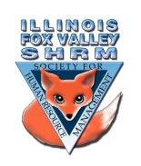
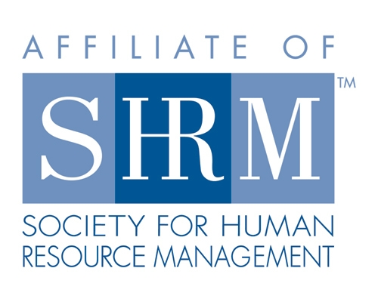

Board of
Board Meeting Minutes
Thursday, August 18, 2022

Sarah Sester called the meeting to order at 1:22pm

- Discuss meeting status and location for next month
- Group agreed to a hybrid meeting for September
- Motion to approve Hybrid meeting made by Lisa, seconded by Judie – Motion carried
- Community Outreach
- Carmen met with small businesses
- Looking for help with recruiting and/or guidance
- Event not yet scheduled
- Looking for speaker to discuss recruiting, screening, background screens
- Suggestion to get a list of questions from the group to see if we can answer in advance or have someone available for them to call with questions

- Certification
- Put together information on scholarship for up to four individuals to obtain scholarships for HR certification
- Next Test in December
- NIU has prep courses starting in September/October
- Suggestion that there be a lottery for who would get the scholarships out of those that apply

- Bylaws
- Kevin spoke to Mary Cheddie and she said to proceed with what we have and to send to Faith

Directors

Officers

President
Sarah Sester
Lisa Gruhlke

President Elect

VP Membership
Sue Oswalt

VP Programs
Kevin Wilson

Treasurer
Sandra Sanchez

Secretary
Victoria Kunz

Directors

Community
Outreach
Carmen Lainez
Susan Brown

Asst VP Membership
Beth Hovious

Asst VP Programs/
Certification
Judie Childress

Member Benefits
Warren Krup

Legislation
Mike Wong

Social Media
Samantha Salinas

Committee Chair

Diversity
Susan Jayne

Member Benefits
Kristin Bartholomew

Dedicated to supporting the continued growth of individuals in the Human Resources profession.
Website: illinoisfoxvalley.shrm.org
Email: illinoisfoxvalleyshrm@yahoo.com

Board of
Board Meeting Minutes continued
Thursday, August 18, 2022

- Programs
- October – Lt. Williams to present on emergency plan for active shooters
- Speaker has been difficult to get a hold of
- Susan Brown has been in contact with him
- November – Panel
- Luke Majkut – recruiting
- Ryan Krup – diversity
- Paul Malon - strategy

- Treasurer
- Accounts in good standing – currently $19,447 in checking account
- Misc.
- Election paperwork should be ready to go out in September
- Chapter received email about Pinnacle Award
- We haven’t applied for this in the past
- Chapter needs to have a major event, initiative, program to apply
- Sue requested information on this award – possibly consider for Strategic Planning next year

Sarah made the motion to adjourn

Lisa & Kevin seconded

Meeting Adjourned at 1:48pm

Directors

Officers

President
Sarah Sester
Lisa Gruhlke

President Elect

VP Membership
Sue Oswalt

VP Programs
Kevin Wilson

Treasurer
Sandra Sanchez

Secretary
Victoria Kunz

Directors

Community
Outreach
Carmen Lainez
Susan Brown

Asst VP Membership
Beth Hovious

Asst VP Programs/
Certification
Judie Childress

Member Benefits
Warren Krup

Legislation
Mike Wong

Social Media
Samantha Salinas

Committee Chair

Diversity
Susan Jayne

Member Benefits
Kristin Bartholomew

Dedicated to supporting the continued growth of individuals in the Human Resources profession.
Website: illinoisfoxvalley.shrm.org
Email: illinoisfoxvalleyshrm@yahoo.com

