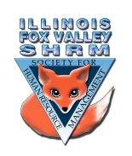
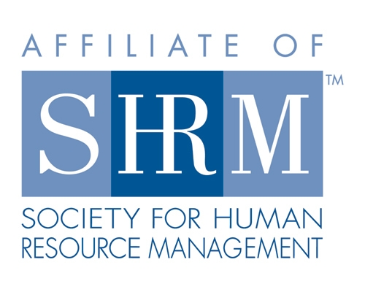

Board of
Board Meeting Minutes
Thursday, July 21, 2022

Lisa Grulke called the meeting to order at 1:03pm

- Discuss meeting status and location for next month
- Could probably do it at ECC even if speaker is remote
-Kevin to check in with speaker and verify whether or not they will be in person
- Group agreed to a hybrid meeting for August
- Mike suggested that we evaluate COVID status/surges before committing to hybrid meetings in the Fall
- Membership
- 74 members
- Sue kicked off August e-blast to announce next meetings
-Scheduled speakers for September & November have swapped months
- Social/Member Event
-Beth and Victoria came up with idea for Paint and Wine night for sometime in October
-Bring in snacks/drinks for members
-Judie has a coworker that does these parties on the side
-Mike to send info regarding place in Elgin
-Board suggested to hold the event on a Thursday evening
-Beth to check budget and review available dates with a few places

- Programs
- August EEOC – Kevin to verify whether or not speaker will be in person
- September meeting – changed to SHRM certification presentation
-SHRM might be able to provide chapter up to 4 coupons to waive application fees
*Remind members about NIU prep course discount
iii. October – Sheriff’s department - present on Active Shooter info
iv. November – Recruiting – Kevin looking into speakers
-Mike has a contact from Elgin Chamber that may be able to help

Directors

Officers

President
Sarah Sester
Lisa Gruhlke

President Elect

VP Membership
Sue Oswalt

VP Programs
Kevin Wilson

Treasurer
Sandra Sanchez

Secretary
Victoria Kunz

Directors

Community
Outreach
Carmen Lainez
Susan Brown

Asst VP Membership
Beth Hovious

Asst VP Programs/
Certification
Judie Childress

Member Benefits
Warren Krup

Legislation
Mike Wong

Social Media
Samantha Salinas

Committee Chair

Diversity
Susan Jayne

Member Benefits
Kristin Bartholomew

Dedicated to supporting the continued growth of individuals in the Human Resources profession.
Website: illinoisfoxvalley.shrm.org
Email: illinoisfoxvalleyshrm@yahoo.com

Board of
Board Meeting Minutes continued
Thursday, June 16, 2022

- Community Outreach
- Alignment group took a break – will come back in August
- Group of small business owners that don’t have a budget for an HR person but needs someone for HR questions reached out to Carmen
-Carmen will be attending the meeting on Friday, July 22nd to see what this group wants/needs and will share with group
- District U46 approach Judie during the school year to see if her company could use someone to help with tasks as part of a life skills/school course
-Carmen also works with U46 – will look into this program to see if there are other opportunities for students to work with members’
- Bylaws
- Still waiting for new bylaw requirements from Mary Cheddie.

- 2023 Board
- Sarah, Kristen and Lisa working on Board Positions for 2023
- Misc. – University of Illinois Springfield student asked board if we could share survey with HR professionals for research
- Survey focuses on how HR professionals handle information security and privacy
- Survey will be confidential – personal information will not be shared
- Results will be made available to the public
- Board passed motion to share survey out
-Will present it at the beginning of the August meeting to explain the survey and stir up interest
Meeting Adjourned at 1:48pm

Directors

Officers

President
Sarah Sester
Lisa Gruhlke

President Elect

VP Membership
Sue Oswalt

VP Programs
Kevin Wilson

Treasurer
Sandra Sanchez

Secretary
Victoria Kunz

Directors

Community
Outreach
Carmen Lainez
Susan Brown

Asst VP Membership
Beth Hovious

Asst VP Programs/
Certification
Judie Childress

Member Benefits
Warren Krup

Legislation
Mike Wong

Social Media
Samantha Salinas

Committee Chair

Diversity
Susan Jayne

Member Benefits
Kristin Bartholomew

Dedicated to supporting the continued growth of individuals in the Human Resources profession.
Website: illinoisfoxvalley.shrm.org
Email: illinoisfoxvalleyshrm@yahoo.com

