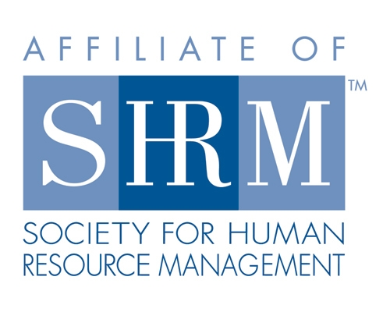

Board of
Meeting Minutes
Thursday, February 10, 2022
Web Meeting 12:00-1:08pm

- Welcome and introductions (12:00pm)
- Sarah Sester welcomed everyone to the call

- Board Reports:
Displayed on screen

- Presentation
- Warren to introduce Sara Schramer for presentation on Wellbeing in the Workplace: Physical, Mental, Emptional and Spiritual Health and Wellbeing
- Legal Update - Mike Wong
-Update employment posters
-Governor’s statement on masks
-local government policies may differ and that is what will be implemented
-Notes on BIPPA
-cases targeting drive cameras
-software used to detect distracted driving
-A lot of presentations coming up from Smith and Amundsen
General meeting adjourned at 1:08pm

Directors

Officers

President
Sarah Sester

President Elect

VP Membership
Sue Oswalt

VP Programs
Kevin Wilson

Treasurer
Lisa Gruhlke

Secretary
Victoria Kunz

Directors

Community
Outreach
Carmen Lainez
Susan Brown

Asst VP Membership
Beth Hovious

Asst VP Programs
Judie Childress
Ron Pryer

Website/Member
Benefits
Warren Krup

Legislation
Mike Wong

Committee Chair

Diversity
Susan Jayne

Social Media
Samantha Salinas

Dedicated to supporting the continued growth of individuals in the Human Resources profession.
Website: illinoisfoxvalley.shrm.org
Email: illinoisfoxvalleyshrm@yahoo.com

