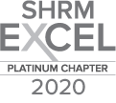
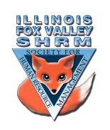
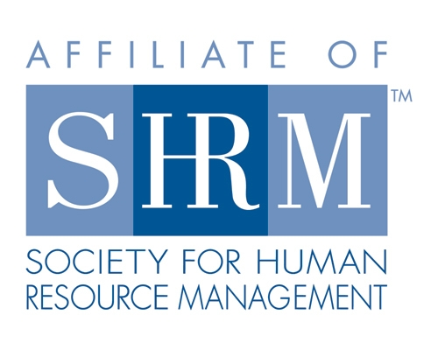

Board of
General Meeting Minutes
Thursday, September 23, 2021
Web Meeting 12:00-1:00pm
- Sarah Sester welcomed everyone to the meeting at 12:01 pm.
- Board Reports:
  - Programs: Kevin said he is working on 2022. February is on Wellness and a SHRM speaker will be presenting in April.
  - Membership: Sue stated that we have 57 members.
  - Website: Kristen said it is up to date.
  - Community Outreach:
    - Carmen talked about District U-46 Explore looking for moderators for their virtual event on October 7th. This is with students attending five 40-minute panels highlighting each of the five U-46 designated career pathways (Arts and Communication, Business/Finance, Health Sciences, Human and Public Services, Liberal Arts, and STEM). As a moderator you will receive a list of questions ahead of time. You will pose those questions to three panelists in related career fields. The goal will be to give students a broad look at each of the panelists’ professions. Students will also have the ability to ask questions using the chat box. Contact Carmen Lainez if you or someone you know are interested.
    - Susan Brown mentioned that the Kane County Sheriff’s Office offers training in Forklift Certification and OSHA.
    - There will also be a free Manufacturing Day Virtual Hiring Event on October 27th. Information on the training classes and virtual event are posted on the ILFVSHRM website (News).
  - Strategic meeting is on October 12th. Any member can send topics to Sarah Sester or let her know if you would like to join the meeting. We will be finalizing the board for 2022.
  - ILSHRM conference is 9/27 – 9/29/21.
  - Presentation started at 12:12 pm. Panel discussion on Recruitment and Retention with panelists Samantha Salinas, Carmen Lainez and Sue Oswalt.
  - Meeting adjourned at 1:05pm.

Directors

Officers

President
Sarah Sester

President Elect

VP Membership
Sue Oswalt

VP Programs
Kevin Wilson

Treasurer
Lisa Gruhlke

Secretary
Victoria Kunz

Directors

Community
Outreach
Carmen Lainez
Susan Brown

Asst VP Membership
Beth Hovious

Asst VP Programs
Judie Childress

Website/Member
Benefits
Warren Krup

Legislation
Mike Wong

Committee Chair

Diversity
Susan Jayne

Social Media
Samantha Salinas

Member Benefits
Kristin Bartholomew

Dedicated to supporting the continued growth of individuals in the Human Resources profession.
Website: illinoisfoxvalley.shrm.org
Email: illinoisfoxvalleyshrm@yahoo.com

