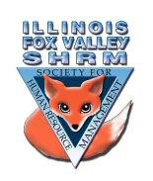
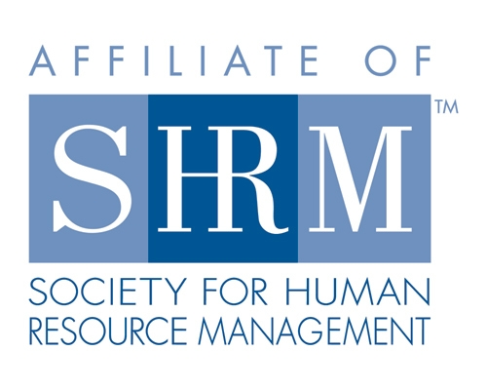

Board of
Board Meeting Minutes
Thursday, April 21, 2022

Sarah called the meeting to order at 1:03pm

- Community Outreach – Carmen
- Met with Alignment regarding job fair
- Event at Elgin and South Elgin High Schools April 27-28th from 10am – 2pm
- In dire need of volunteers
- Beth has signed up and Sarah Sester is looking at availability
- Event provides high schoolers the opportunity to meet with employers from different industries.
- Programs
- May Meeting – can the May meeting be in person/hybrid
-Kevin to reach out to Bob Lemke for availability to travel to Elgin
- June Meeting and August meetings have speakers
- Still looking for topics and presenters in September, October & November
- Kevin has been reaching out to people regarding DEI
- Wants to make sure topics are relevant

- Membership
- Roughly at 70 members
- Trying to get confirmation from national to confirm new members are staying on our chapter’s roster
- Kristen to send list to Mary Cheddie to help confirm enrollments
- Delight is transitioning out of our region and Faith is taking over – has been travelling a lot lately
- Beth and Sue to work on Social/Not a Social – looking towards an event in Fall

- Update on Bylaws
- Lisa and Sarah have worked on these and sent to Mike Wong for review
- There is a new bylaw format that will be updated again
- Mary Cheddie suggested waiting on the bylaw submittal until the most recent set of changes are made
Meeting Adjourned at 1:14pm

Directors

Officers

President
Sarah Sester
Lisa Gruhlke

President Elect

VP Membership
Sue Oswalt

VP Programs
Kevin Wilson

Treasurer
Sandra Sanchez

Secretary
Victoria Kunz

Directors

Community
Outreach
Carmen Lainez
Susan Brown

Asst VP Membership
Beth Hovious

Asst VP Programs/
Certification
Judie Childress

Member Benefits
Warren Krup

Legislation
Mike Wong

Social Media
Samantha Salinas

Committee Chair

Diversity
Susan Jayne

Member Benefits
Kristin Bartholomew

Dedicated to supporting the continued growth of individuals in the Human Resources profession.
Website: illinoisfoxvalley.shrm.org
Email: illinoisfoxvalleyshrm@yahoo.com

