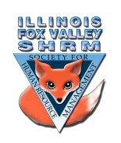
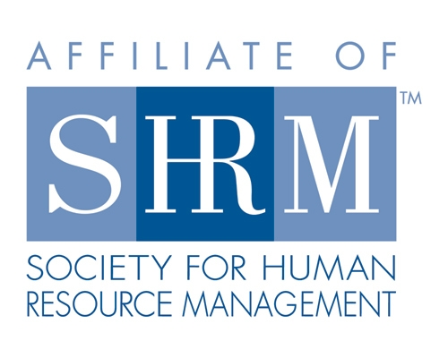

Board of
Board Meeting Minutes
Thursday, May 20, 2021
Start time 1:04 pm

Sarah Sester called the meeting to order at 1:04pm
– things are moving along well

Membership – do we know where the new members have come from?
-Excited about college work with Judson and ECC
-corresponding with two students
-would be cool if we could pair them with a board member
-Eblast to go out in June to promote group
-Picnic in the park – Elgin Country Club said we could use their patio
-just depends on the date
-Sue wants to keep it pretty casual
-bring a coffee – talk about hot topics
-get your feet wet to reemerge with other people
-Sarah agrees on an informal format
-maybe we can get students to come to picnic
-Social not a social – Sue is working on something cool

Programs
-new members suggested need to know topics – problems people are focusing day to day
-networking
-Recruiting, manager training, performance management, compensation section –

FMLA, ADA, measuring productivity
-other chapters are doing networking events after the meeting – stay on, pick a topic
-No one lined up for September, October, November
-Warren – contacted by Greg Wisemendal – to give presentation
-Sarah Schramer – possibly look to her for presentation in the fall
-thinks Kevin has been doing such a good job and Sue’s enthusiasm is fantastic

Directors

Officers

President
Sarah Sester

President Elect

VP Membership
Sue Oswalt

VP Programs
Kevin Wilson

Treasurer
Lisa Gruhlke

Secretary
Victoria Kunz

Directors

Community
Outreach
Carmen Lainez
Susan Brown

Asst VP Membership
Beth Hovious

Asst VP Programs
Judie Childress
Ron Pryer

Website/Member
Benefits
Warren Krup

Legislation
Mike Wong

Committee Chair

Diversity
Susan Jayne

Social Media
Samantha Salinas

Dedicated to supporting the continued growth of individuals in the Human Resources profession.
Website: illinoisfoxvalley.shrm.org
Email: illinoisfoxvalleyshrm@yahoo.com

Board of
Board Meeting Minutes (cont.)

Future meetings
-booked for July
-June – test out hybrid set up - presenter will be virtual – board members in the small room
-Kristen has webcam
-July meeting - $20 in person, $10 virtual

Community Outreach
-U46 program went well
-Sue – if we could do something else similar, for future generations that would be great

Dual Membership – finalizing info to review email before it goes out to members
-how will student membership work
-Kevin suggested adding a college relations committee member
-previous group did career nights, participated in resume writing workshops

By Laws – Sarah to review and finalize then send to national
Insurance – Lisa working on it

Meeting Adjourned

Directors

Officers

President
Sarah Sester

President Elect

VP Membership
Sue Oswalt

VP Programs
Kevin Wilson

Treasurer
Lisa Gruhlke

Secretary
Victoria Kunz

Directors

Community
Outreach
Carmen Lainez
Susan Brown

Asst VP Membership
Beth Hovious

Asst VP Programs
Judie Childress
Ron Pryer

Website/Member
Benefits
Warren Krup

Legislation
Mike Wong

Committee Chair

Diversity
Susan Jayne

Social Media
Samantha Salinas

Dedicated to supporting the continued growth of individuals in the Human Resources profession.
Website: illinoisfoxvalley.shrm.org
Email: illinoisfoxvalleyshrm@yahoo.com

Board of
Board Meeting Minutes (cont.)

-Delight suggested removing the requirement to vote on new members
-Sarah will remove it, we will have to vote then send to national SHRM for approval

Have we received quotes for insurance?
-Not yet
-DNO we have always had
-General Liability – Elgin Community College made us carry it
Platinum award plaques
-No actual plaques
-Kristen to advertise this award via email and social media
Looking for different ideas to promote our group
-HR walking club?
-Missing networking/social aspect
-Golf? Top Golf?
-Picnic
-St. Charles has nice parks, Wasco?, Potawatomi
-In person meeting at the park
What do you prefer for board meetings?
-After the meeting
-Most people could go either way
Meeting adjoured at 9:15

Directors

Officers

President
Sarah Sester

President Elect

VP Membership
Sue Oswalt

VP Programs
Kevin Wilson

Treasurer
Lisa Gruhlke

Secretary
Victoria Kunz

Directors

Community
Outreach
Carmen Lainez
Susan Brown

Asst VP Membership
Beth Hovious

Asst VP Programs
Judie Childress
Ron Pryer

Website/Member
Benefits
Warren Krup

Legislation
Mike Wong

Committee Chair

Diversity
Susan Jayne

Social Media
Samantha Salinas

Dedicated to supporting the continued growth of individuals in the Human Resources profession.
Website: illinoisfoxvalley.shrm.org
Email: illinoisfoxvalleyshrm@yahoo.com

