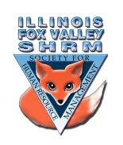
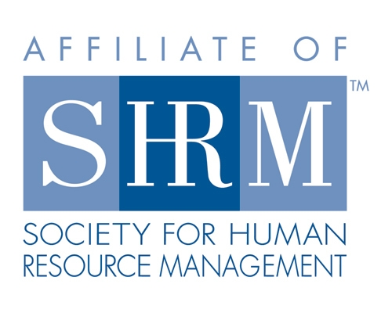

Board of
Meeting Minutes
Thursday, April 15, 2021
Web Meeting 12:00-1:00pm

- Welcome and introductions (12:01pm)
-Sarah Sester welcomed everyone to the call
- Board Reports:
- Financial – Lisa
- Finances in good standing
- $25k in assets between CD and savings
- Dual membership – IL SVSHRM may owe us a refund if National SHRM membership expires after August
- Membership – Sue O./Beth
- Welcome everyone and new members
- 48 members
- reminder on dual membership
-Coming up in August
-Sign up for SHRM national and IL FV SHRM at the same time
- Programs- Kevin
- Today – John Newton – managing the remote workforce
May – mini workshop on racial equit
- y
- June – workplace investigations
- July – legal update
- August – Sue Jayne – Diversity & belonging
- Working on the rest of the year – open to suggestions on topics & speakers
- Community Outreach – Carmen
- Met with U46 pathways program
- Online – May 3rd (1-1:50pm)
-Looking for someone to represent HR and talk about HR and day in the life of HR professional
-Let her know if you are interested in presenting
- Working with Susan Brown from Kane County Sheriff’s department on outreach
- Legal Update – Peter Hanson
- New COBRA notices

Directors

Officers

President
Sarah Sester

President Elect

VP Membership
Sue Oswalt

VP Programs
Kevin Wilson

Treasurer
Lisa Gruhlke

Secretary
Victoria Kunz

Directors

Community
Outreach
Carmen Lainez
Susan Brown

Asst VP Membership
Beth Hovious

Asst VP Programs
Judie Childress
Ron Pryer

Website/Member
Benefits
Warren Krup

Legislation
Mike Wong

Committee Chair

Diversity
Susan Jayne

Social Media
Samantha Salinas

Dedicated to supporting the continued growth of individuals in the Human Resources profession.
Website: illinoisfoxvalley.shrm.org
Email: illinoisfoxvalleyshrm@yahoo.com

Board of
Meeting Minutes (cont.)
Thursday, April 15, 2021
Web Meeting 12:00-1:00pm

-released as part of American Rescue Act
-provide assistance to those enrolled in COBRA
-Will have to issue new update to employees

- Kevin introduced John Newton – 12:22pm
-Presentation: How to take managing the remote workforce to the next level!

- Meeting concluded at 1:11pm

Directors

Officers

President
Sarah Sester

President Elect

VP Membership
Sue Oswalt

VP Programs
Kevin Wilson

Treasurer
Lisa Gruhlke

Secretary
Victoria Kunz

Directors

Community
Outreach
Carmen Lainez
Susan Brown

Asst VP Membership
Beth Hovious

Asst VP Programs
Judie Childress
Ron Pryer

Website/Member
Benefits
Warren Krup

Legislation
Mike Wong

Committee Chair

Diversity
Susan Jayne

Social Media
Samantha Salinas

Dedicated to supporting the continued growth of individuals in the Human Resources profession.
Website: illinoisfoxvalley.shrm.org
Email: illinoisfoxvalleyshrm@yahoo.com

