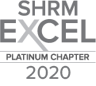
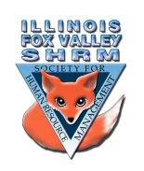
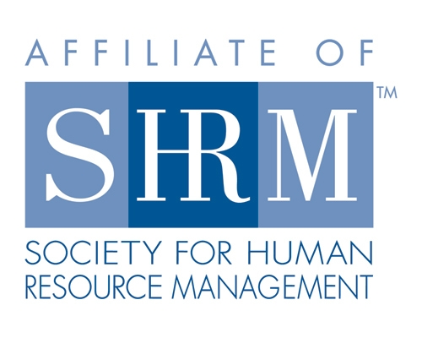

Board of
Meeting Minutes
Thursday, June 17, 2021
Web Meeting 12:00-1:00pm

- Welcome and introductions (12:02pm)
- Sarah Sester welcomed everyone to the call
- Board testing hybrid format today
- Hybrid meeting being offered to members next month
- Watch for additional info on Dual Membership
- SHRM national meeting – in Las Vegas
- IL SHRM meeting to come – last week of September – will be all virtual – meetings can be on demand so if you cannot attend at the date and time, the meetings will be available for another 30 days
- ilshrm.org

- Board Reports:
- Financial – Lisa
- Good standing
- $24k in assets, $15k in CD and $9k in bank account
- Membership – Sue O./Beth
- 54 members
- One of the newest members has volunteered to do a book club
-coffee gathering logistics
-to be discussed in board meeting
- Website – Warren
- Sponsor Kronos for July meeting
- Programs- Kevin
- Focus groups have lead to some new topics
- July – legal update
- August – Sue Jayne – Diversity & belonging
- September – members sharing session
- October – performance management for smaller organizations
- November leadership skills to new heights? – Sue O to work on that

- Sarah Sester – presented Laura Miller, director of IL SHRM
-Today’s presentation: Conducting Internal Investigations

- Presentation and general meeting ended at 12:58pm

Directors

Officers

President
Sarah Sester

President Elect

VP Membership
Sue Oswalt

VP Programs
Kevin Wilson

Treasurer
Lisa Gruhlke

Secretary
Victoria Kunz

Directors

Community
Outreach
Carmen Lainez
Susan Brown

Asst VP Membership
Beth Hovious

Asst VP Programs
Judie Childress
Ron Pryer

Website/Member
Benefits
Warren Krup

Legislation
Mike Wong

Committee Chair

Diversity
Susan Jayne

Social Media
Samantha Salinas

Dedicated to supporting the continued growth of individuals in the Human Resources profession.
Website: illinoisfoxvalley.shrm.org
Email: illinoisfoxvalleyshrm@yahoo.com

