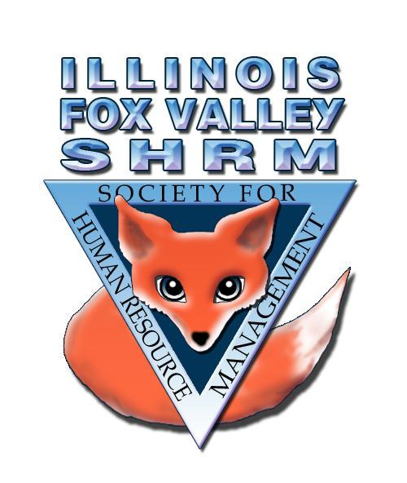
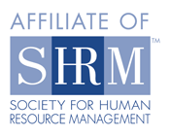
2020 MEMBERSHIP RENEWAL/INVOICE

Dear Illinois Fox Valley SHRM Member:

We are excited about the continued growth and development of our Fox Valley SHRM chapter as we plan for 2020. We hope you plan to remain with us as we grow!

Your Illinois Fox Valley SHRM membership is an annual membership and will expire on December 31st, 2019. Our Board voted unanimously to keep dues amounts the same as last year.

Please remember that our chapter is a “100% SHRM chapter” which means you must keep your membership with national SHRM up to date at all times during the year.

Dues: All memberships are for the period of January through December:

Renewing Primary Member (first member from a company) Due 12/31/18 $100.00
Renewing Secondary Member (additional members from company) Due 12/31/18 $ 80.00
Student Member - HR Related Field of Study Due 12/31/18 $ 50.00
Transitional Member – contact VP Membership to discuss options.

Name: ____________________________________ Job Title: ________________________________
Company Name: _____________________________Address:________________________________
City: _____________________________ State: _____________________ Zip: _________________
Telephone: __________________________ Fax Number: ___________________________________
Email Address: _______________________________________
National SHRM Membership ID# (Required for Membership) ______________________
National SHRM Membership Expiration Date: _____________________
National SHRM Membership Type: Professional ❑ General ❑ Associate ❑ Student ❑
HR Certifications: SPHR ❑ PHR ❑ SHRM-SCP ❑ SHRM-CP ❑ Other _________________

Member Signature: ___________________________________________ Date: _________________

(SHRM Purposes Only) Check Number: __________ Amount: _________ SHRM Membership Verified: ________

